LABORATORY EXERCISE 1
IDE SETUP, BASIC I/O, AND PROGRAMMING CONCEPTS WITH GITHUB VERSION CONTROL

Learning Objectives
- Set up and configure an Integrated Development Environment (IDE) for programming.
- Demonstrate basic input and output (I/O) operations in a programming language (e.g., C++, Java, or Python).
- Review and apply fundamental programming concepts such as variables, data types, and control structures.
- Initialize and manage a GitHub repository for version control of programming projects.
- Document and commit changes in GitHub for project tracking.

Prerequisite student experiences and knowledge
Students should be familiar with basic computer operations and have strong knowledge of programming fundamentals such as syntax, variables, and control flow. Basic understanding of file management and access to a GitHub account..

Background
AnIntegrated Development Environment (IDE) provides tools to write, compile, and run programs efficiently. Performing basic I/O operations is essential for building interactive applications. In addition, understanding fundamental programming conceptsserves as the foundation for advanced programming tasks.
Version control through GitHub enables students to manage code changes, collaborate effectively, and maintain project history. It is widely used in professional software development to organize and track project progress.

Materials/Resources
- PC/Laptop with Internet connection
- Installed IDE (such as Dev-C++, Eclipse, PyCharm, or Visual Studio Code)
- Git and GitHub account
- Web Browser (Google Chrome, Mozilla Firefox, or Microsoft Edge)
- Documentation tool (e.g., Microsoft Word)

Laboratory Activity
Instructions:
- IDE Setup
    - Install and configure an IDE of your choice (Dev-C++, Visual Studio Code, Eclipse, or PyCharm).
    - Capture a screenshot of the installed IDE.
- Basic Input and Output Program
    - Create a simple program in your chosen language that:
      - Accepts the user’s full name and age.
      - Displays a greeting message using the provided input.
    - Example Output:
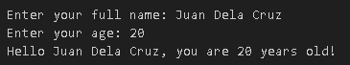
    - Run and test the program. Take a screenshot of the output.
- Recap of Programming Concepts
    - Modify your program to include the following:
      - A variable that stores the current year.
      - A calculation shows when the user will turn 60 years old.
    - Example Output:
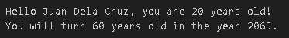
- GitHub Repository Setup
    - Create a GitHub repository named **IDE-BasicIO-Lab**.
    - Initialize your project folder with Git.
    - Commit your program files to the repository with the message:
*“Initial commit - Basic I/O Program”*
    - Push your project to GitHub.
    - Provide the repository link in your documentation.

Question
- What are the advantages of documenting changes in your code using Git commits?
For me, the advantage of documenting changes in code using Git commits is that it creates a clear and organized development history. It helps me track what changes were made, when they were made, and why. This makes debugging easier, especially when something breaks, because I can go back and find the exact commit that introduced the issue.
- What challenges did you face in setting up your IDE and connecting it to GitHub?
One of the main challenges in setting up my IDE and connecting it to GitHub was configuring SSH (Secure Shell). keys properly. At first, I didn’t fully understand how SSH authentication worked, which caused issues when trying to push or pull from remote repositories.
- How does reviewing basic I/O operations strengthen your programming skills?
Reviewing basic I/O operations strengthens my programming skills by reinforcing how data flows between a program and its environment. It helps me understand how to read user input, handle files, and display output effectively, which are all essential for building interactive and practical applications.

Output / Results
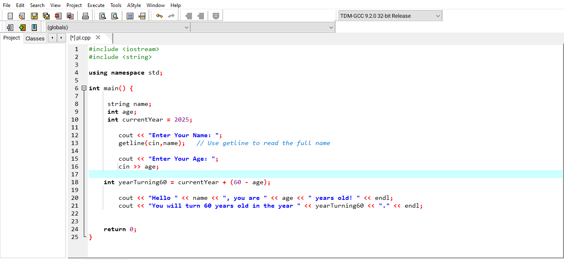
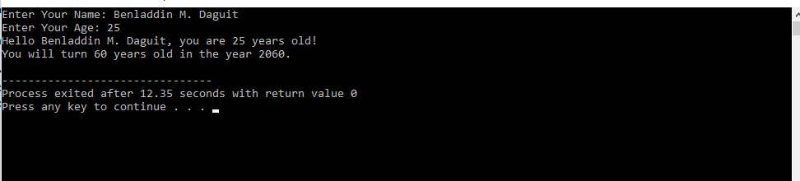

Conclusion
Using Git commits, setting up an IDE with GitHub, and understanding basic I/O operations are all fundamental aspects of becoming a better programmer. They help improve code organization, collaboration, problem-solving, and overall development efficiency. By learning these skills, I feel more confident in handling real-world coding challenges and building more reliable and maintainable software.

